Cosmic Forms – Kate Murdoch
fortyfivedownstairs
September 22 – October 3 2026

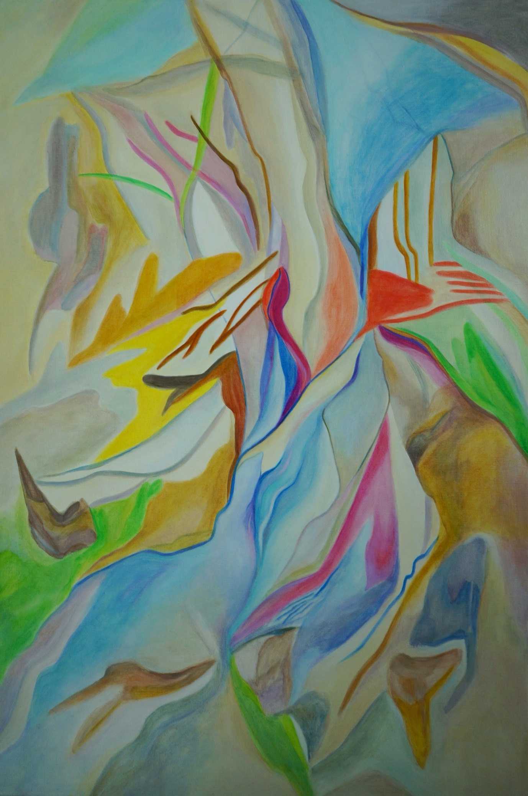
Shenpa
90cm x 60cm
Oil on linen
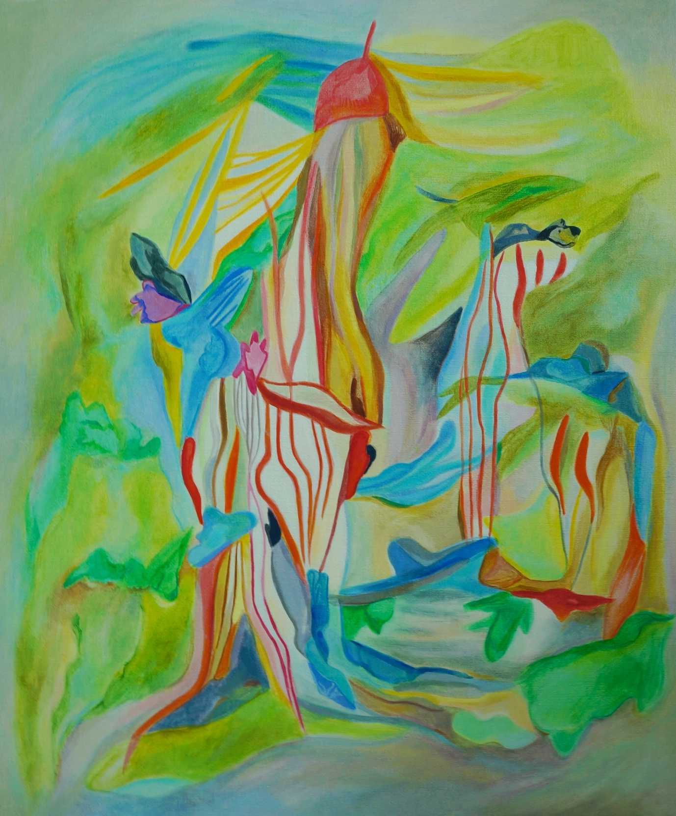
Jardin d'hiver
60cm x 50cm
Oil on linen

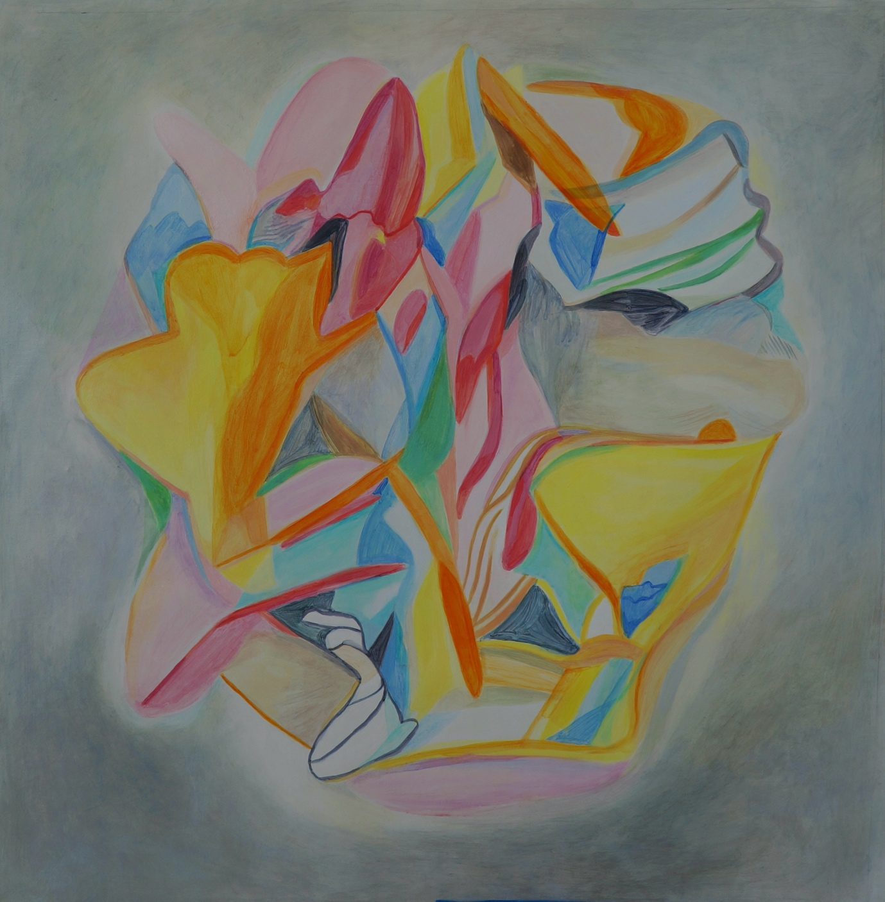
As above, so below
50cm x 50cm
Acrylic on polycotton

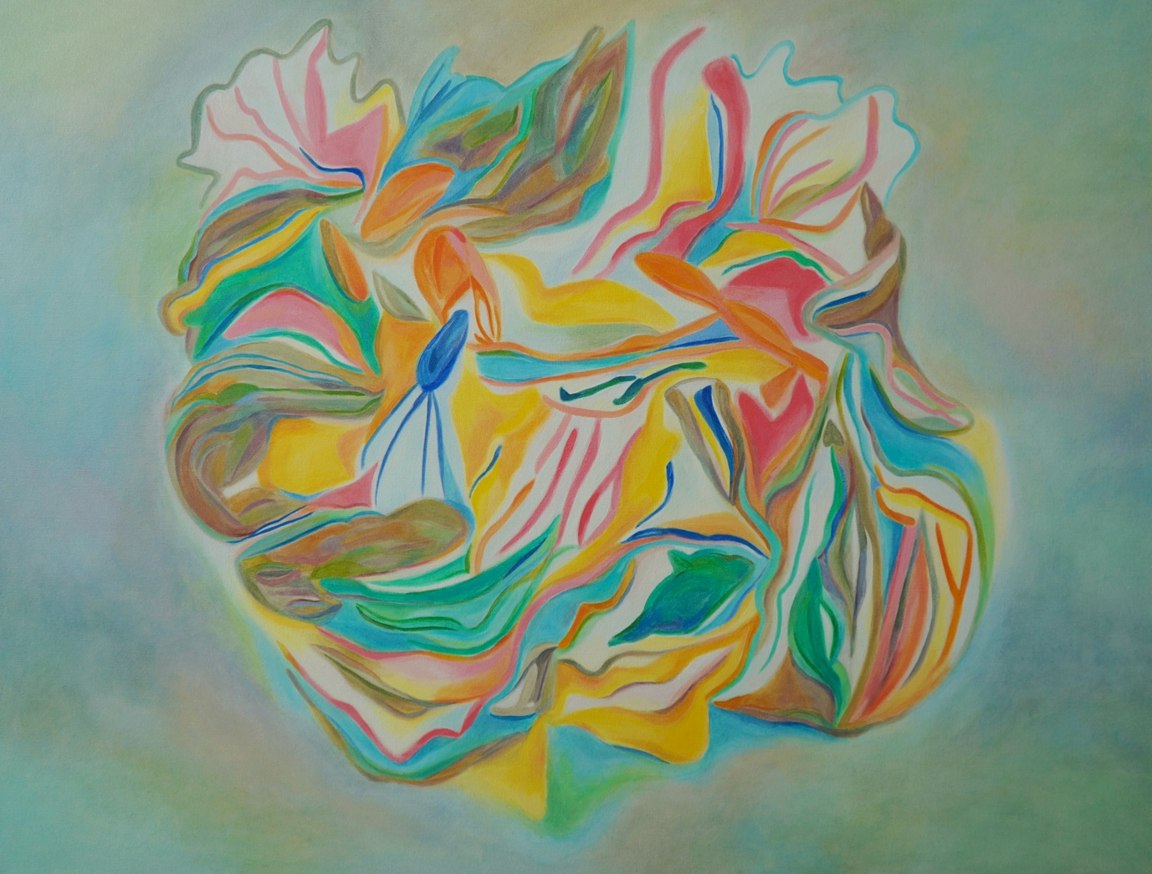
Chrysalis
87cm x 112cm
Oil on canvas

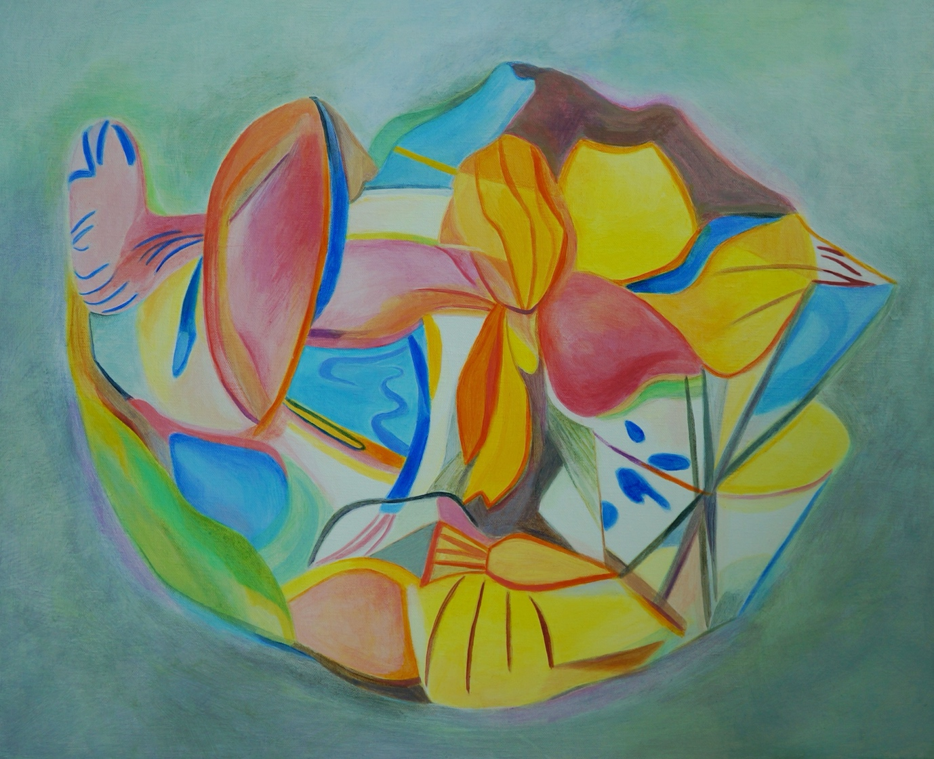
Cornucopia
51cm x 61.5cm
Acrylic on linen

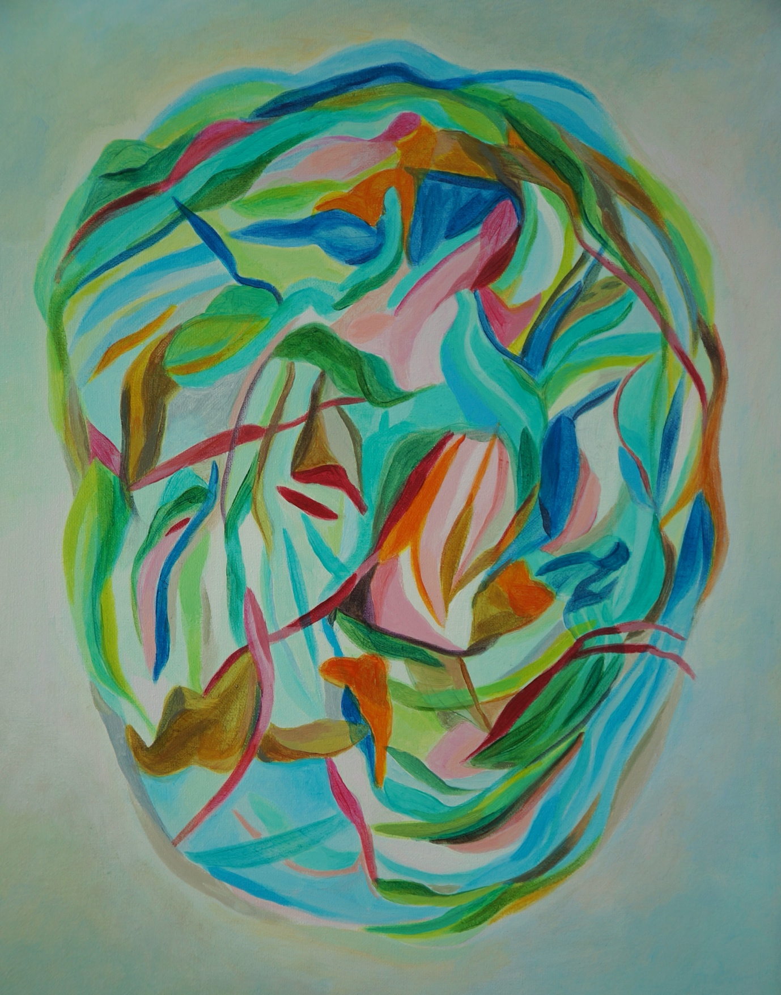
Aqua Profonda
40.5cm x 30cm
Acrylic on polycotton

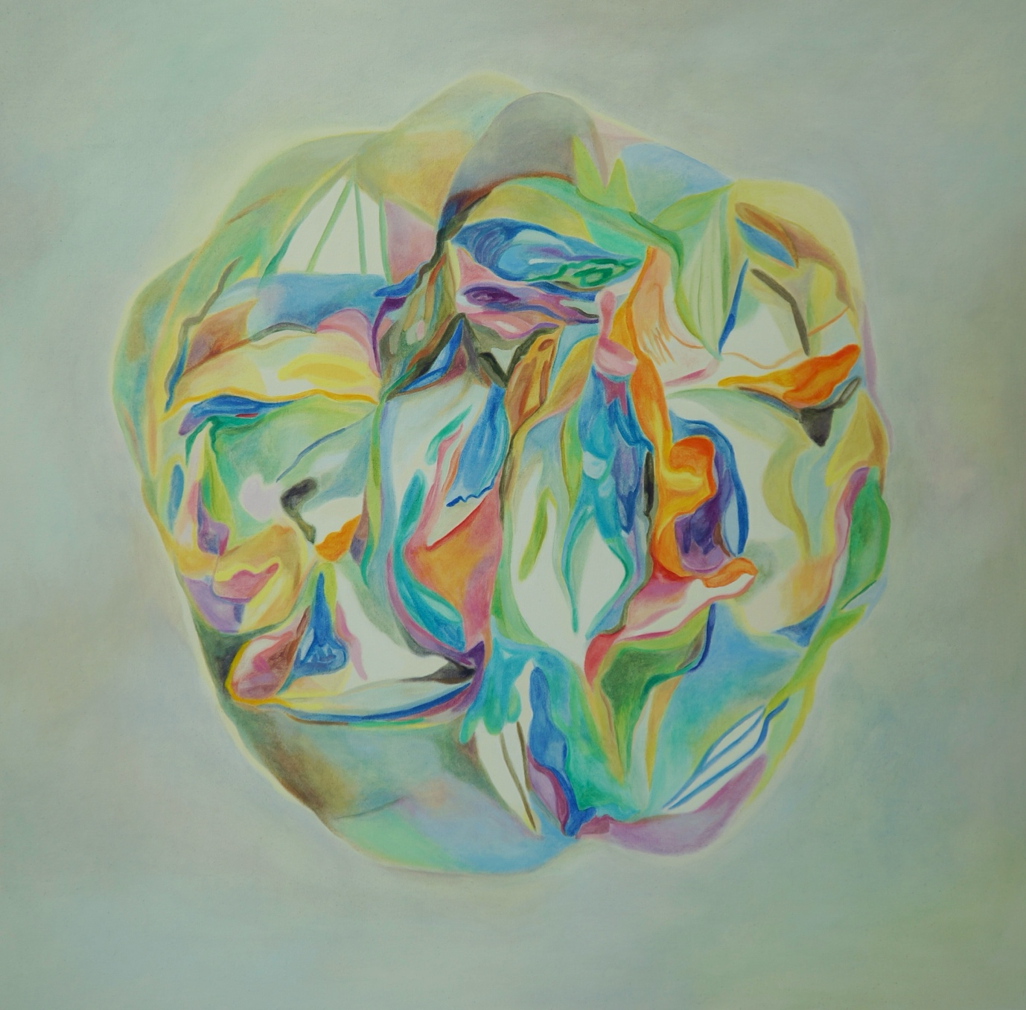
Chance Infinie
92cm x 92cm
Oil on canvas

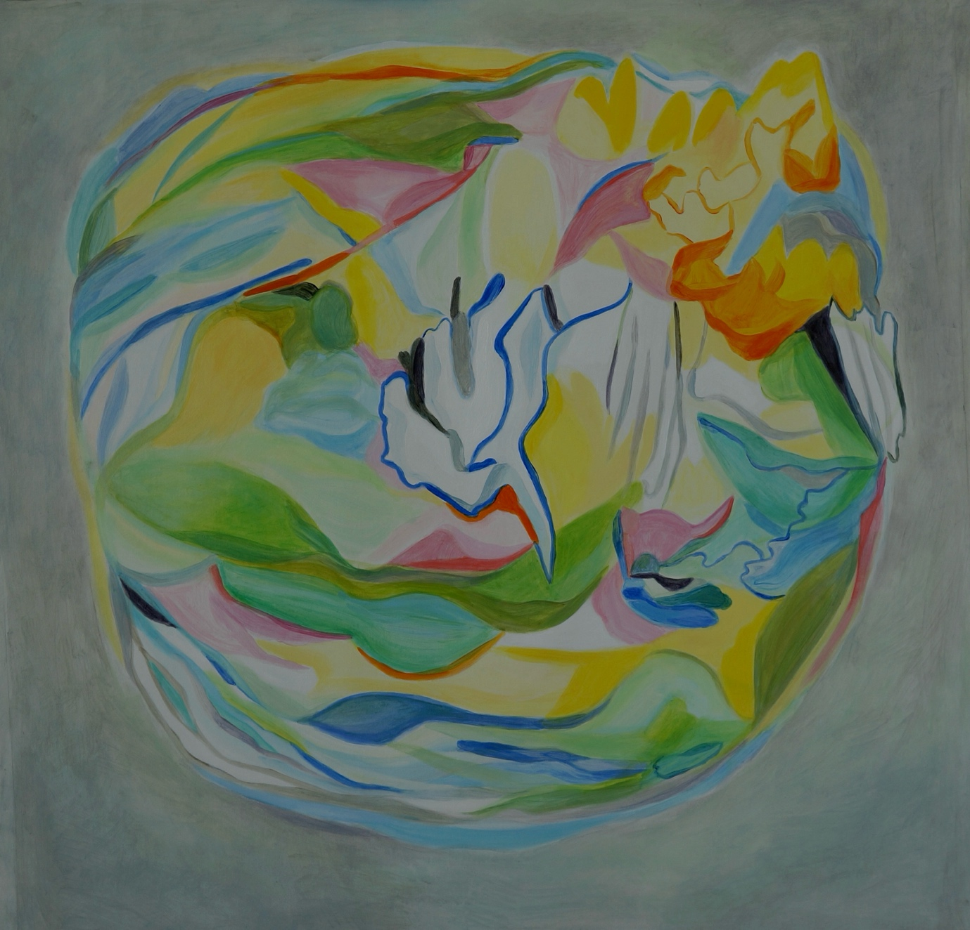
Let the light in
50cm x 50cm
Acrylic on polycotton

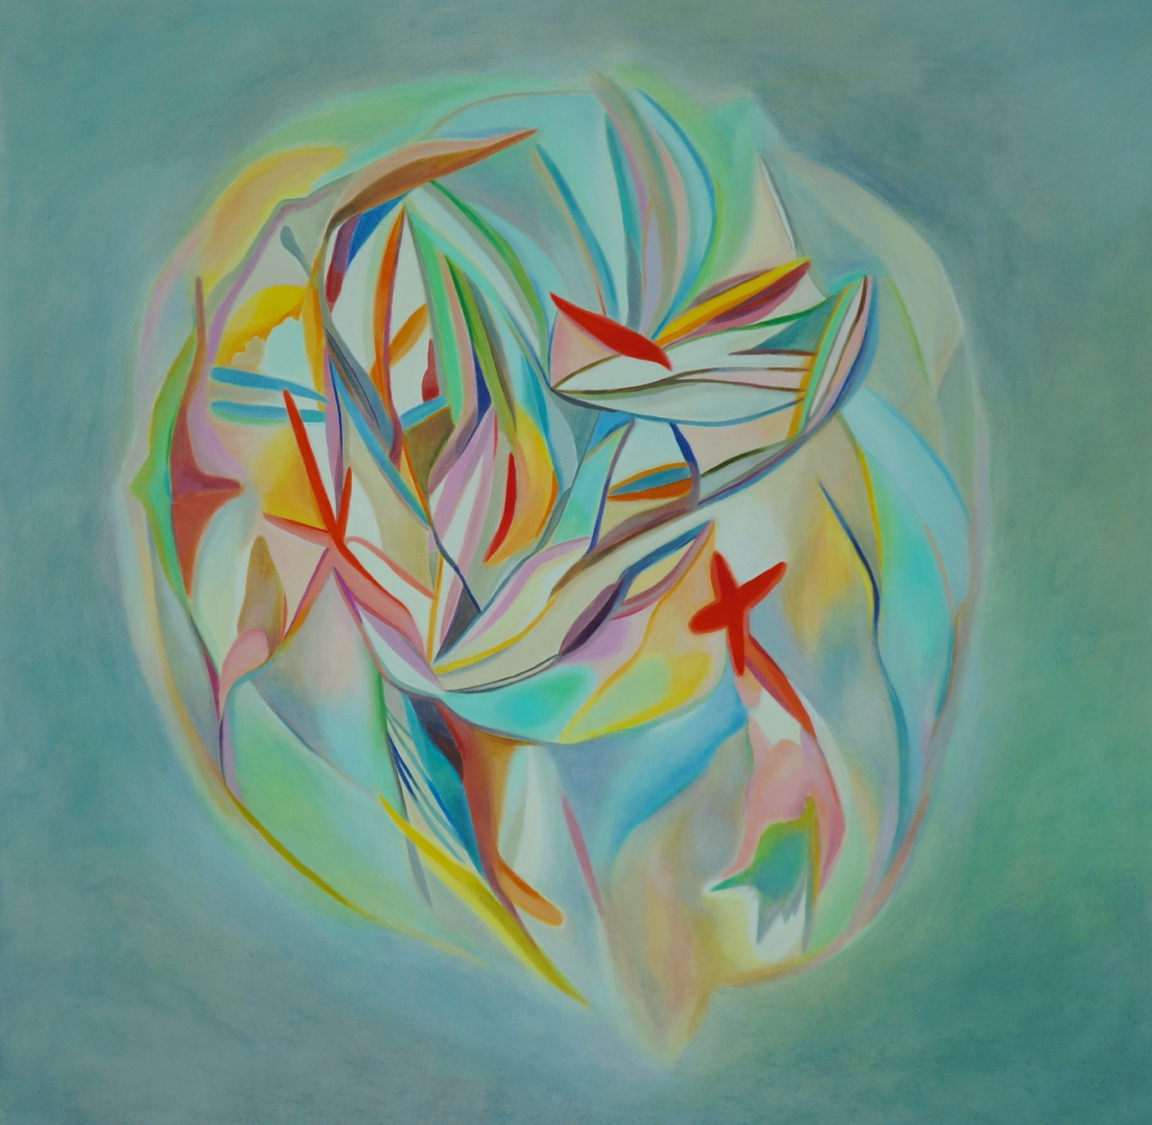
Inflection Point
97cm x 97cm
Oil on canvas

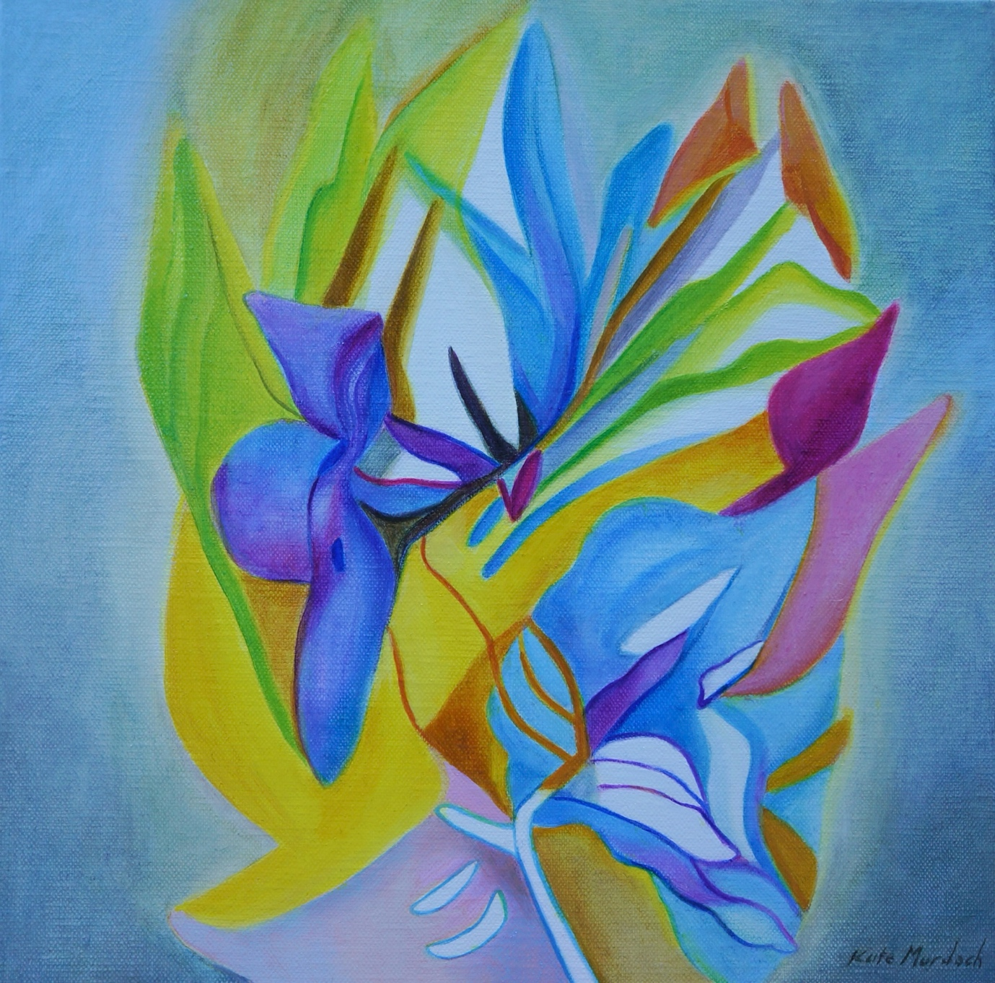
Luctor et Emergo
30.5cm x 30.5cm
Oil on linen

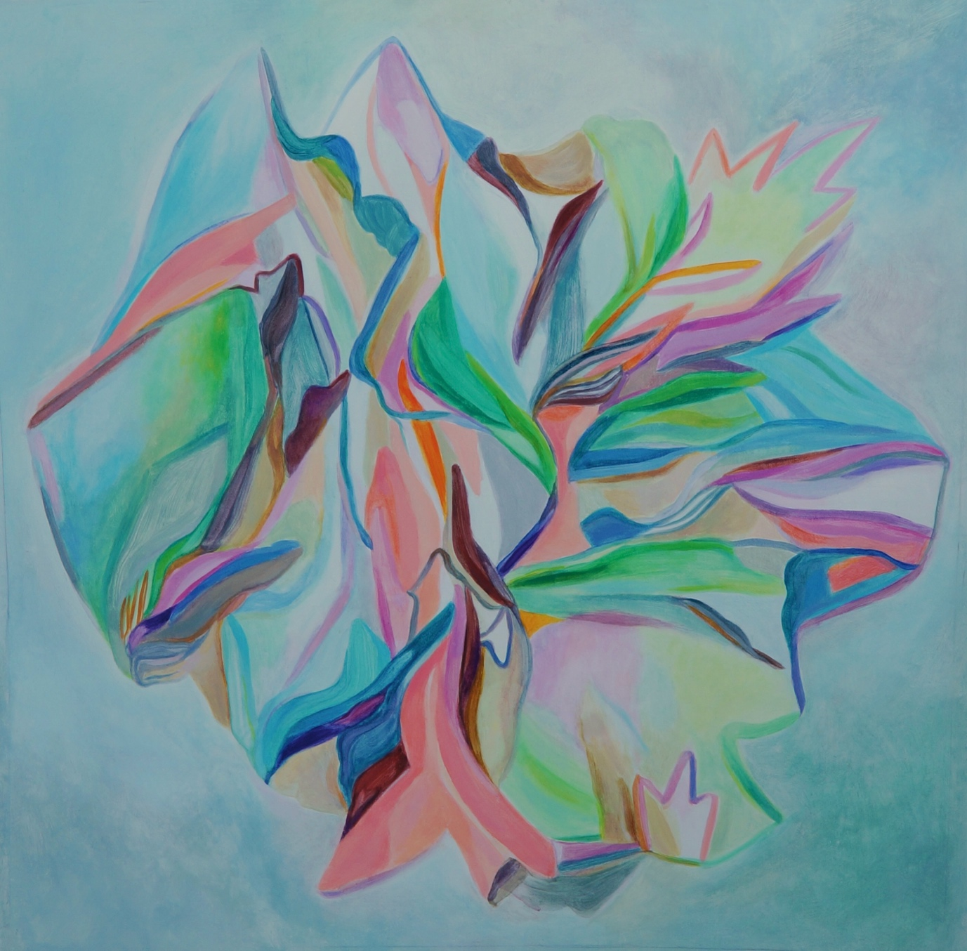
Fluere
50cm x 50cm
Oil on polycotton

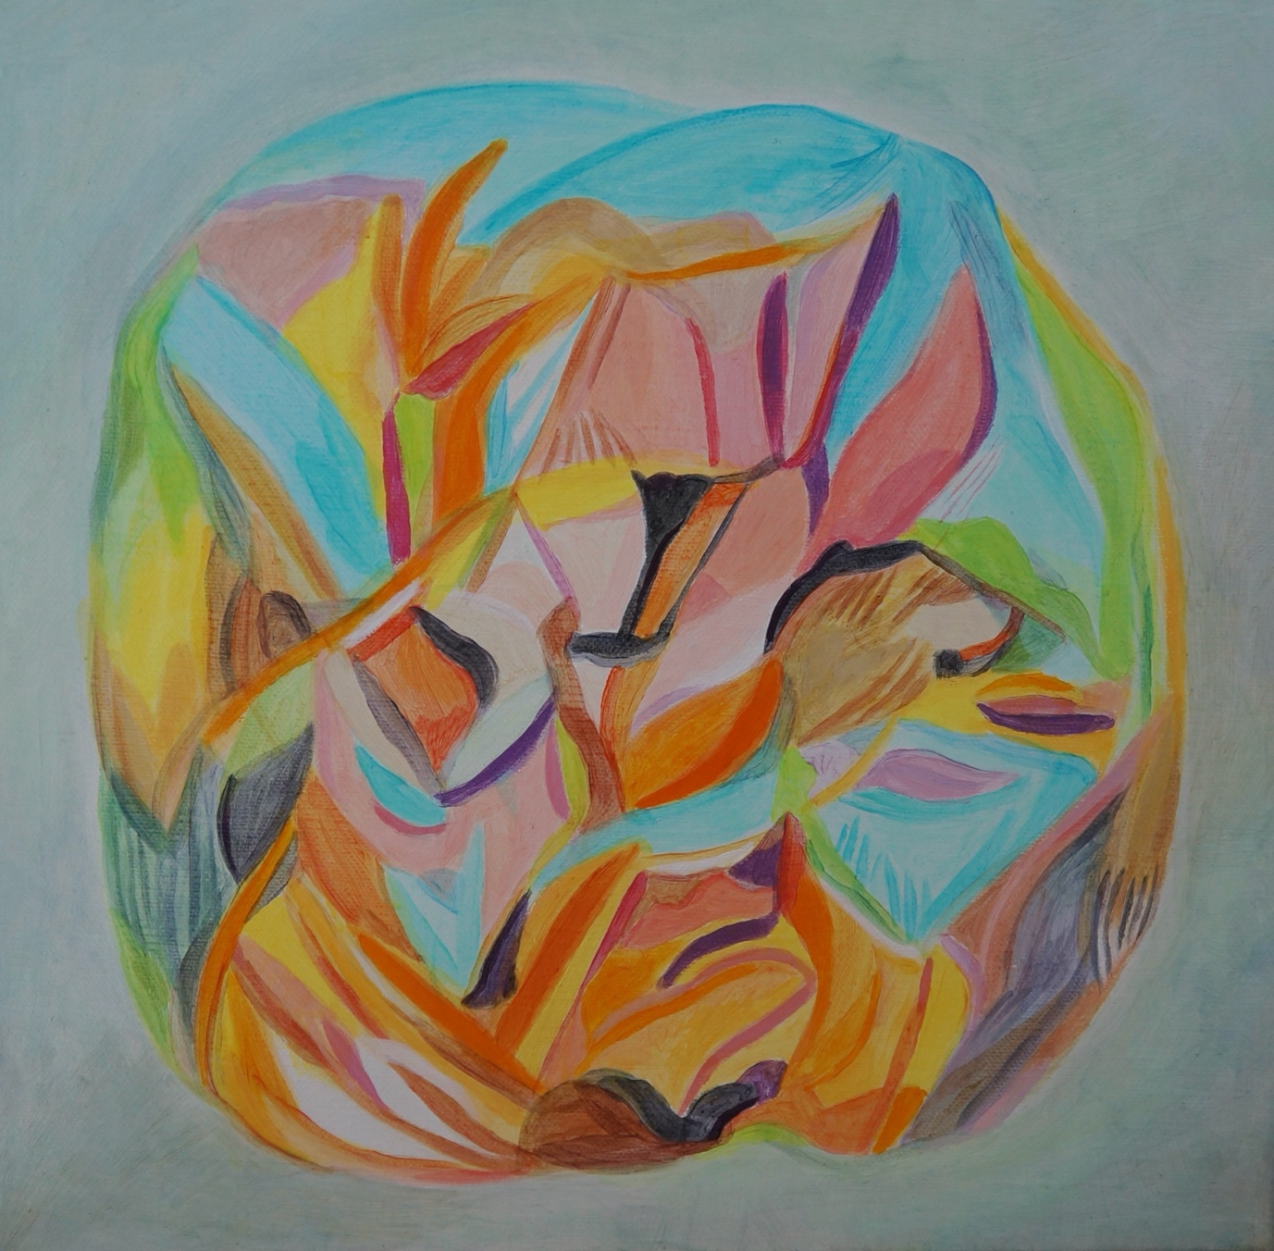
Arise
30.5cm x 30.5cm
Acrylic on linen

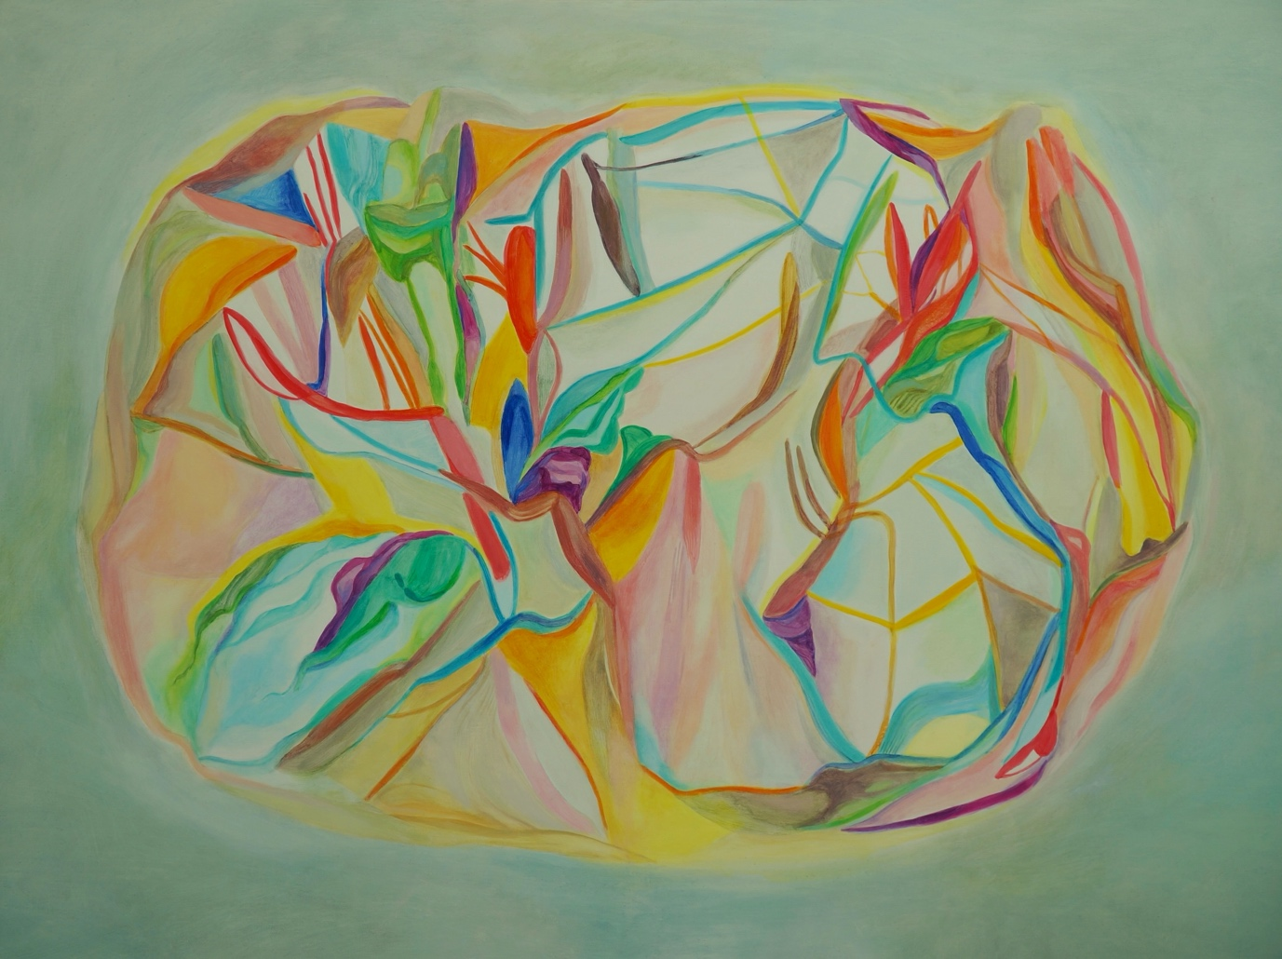
Ember
60cm x 91.5cm
Oil on linen

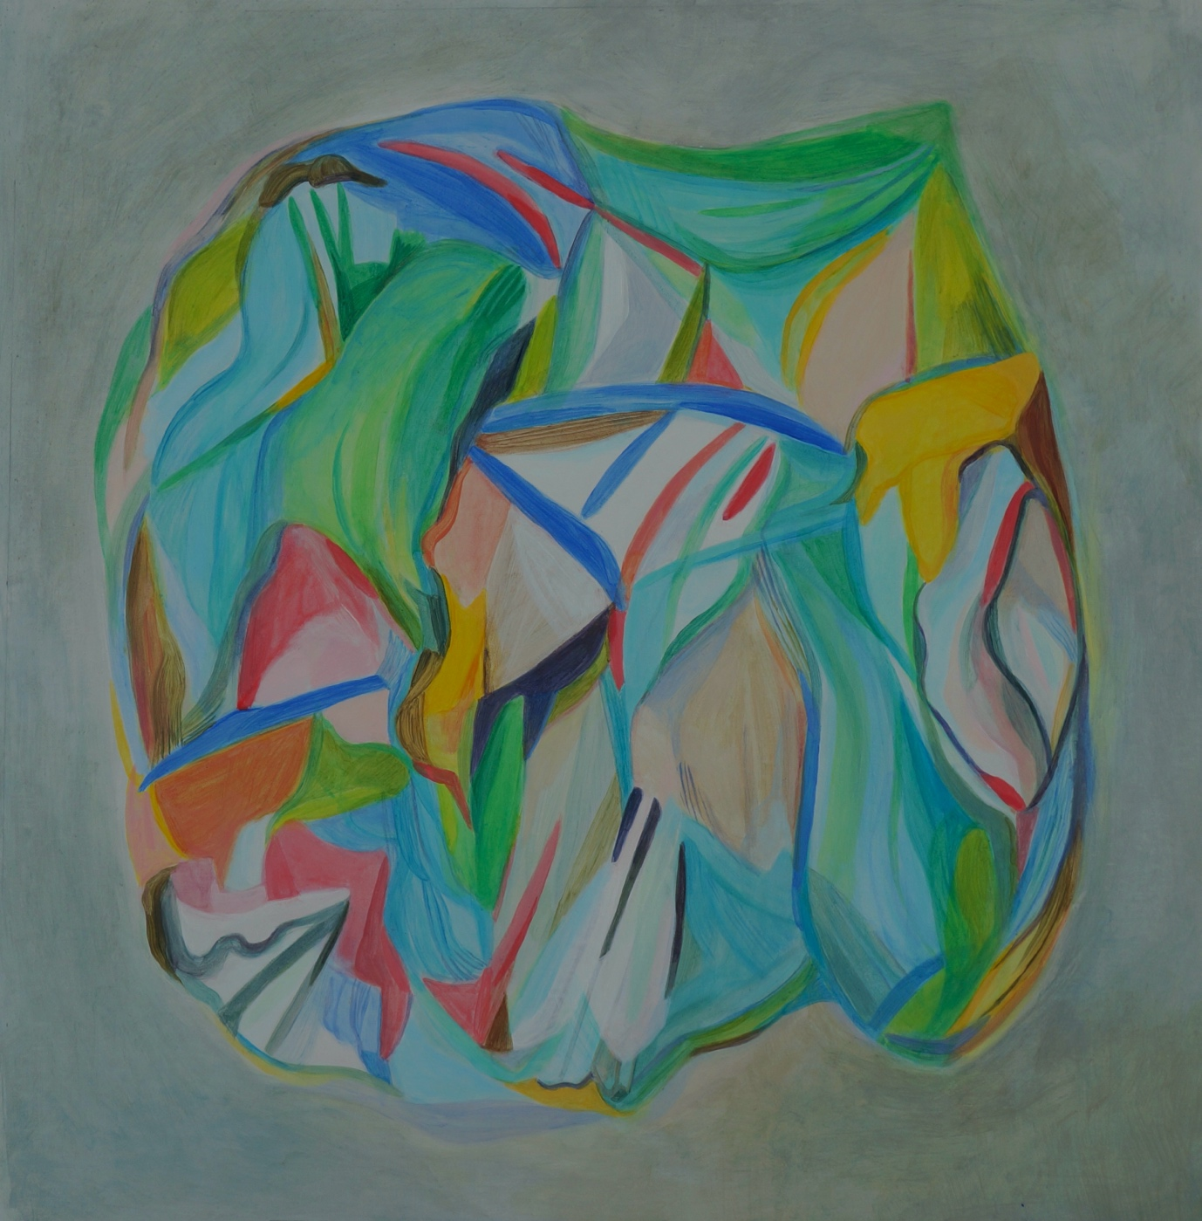
Tide Forms
50cm x 50cm
Acrylic on polycotton

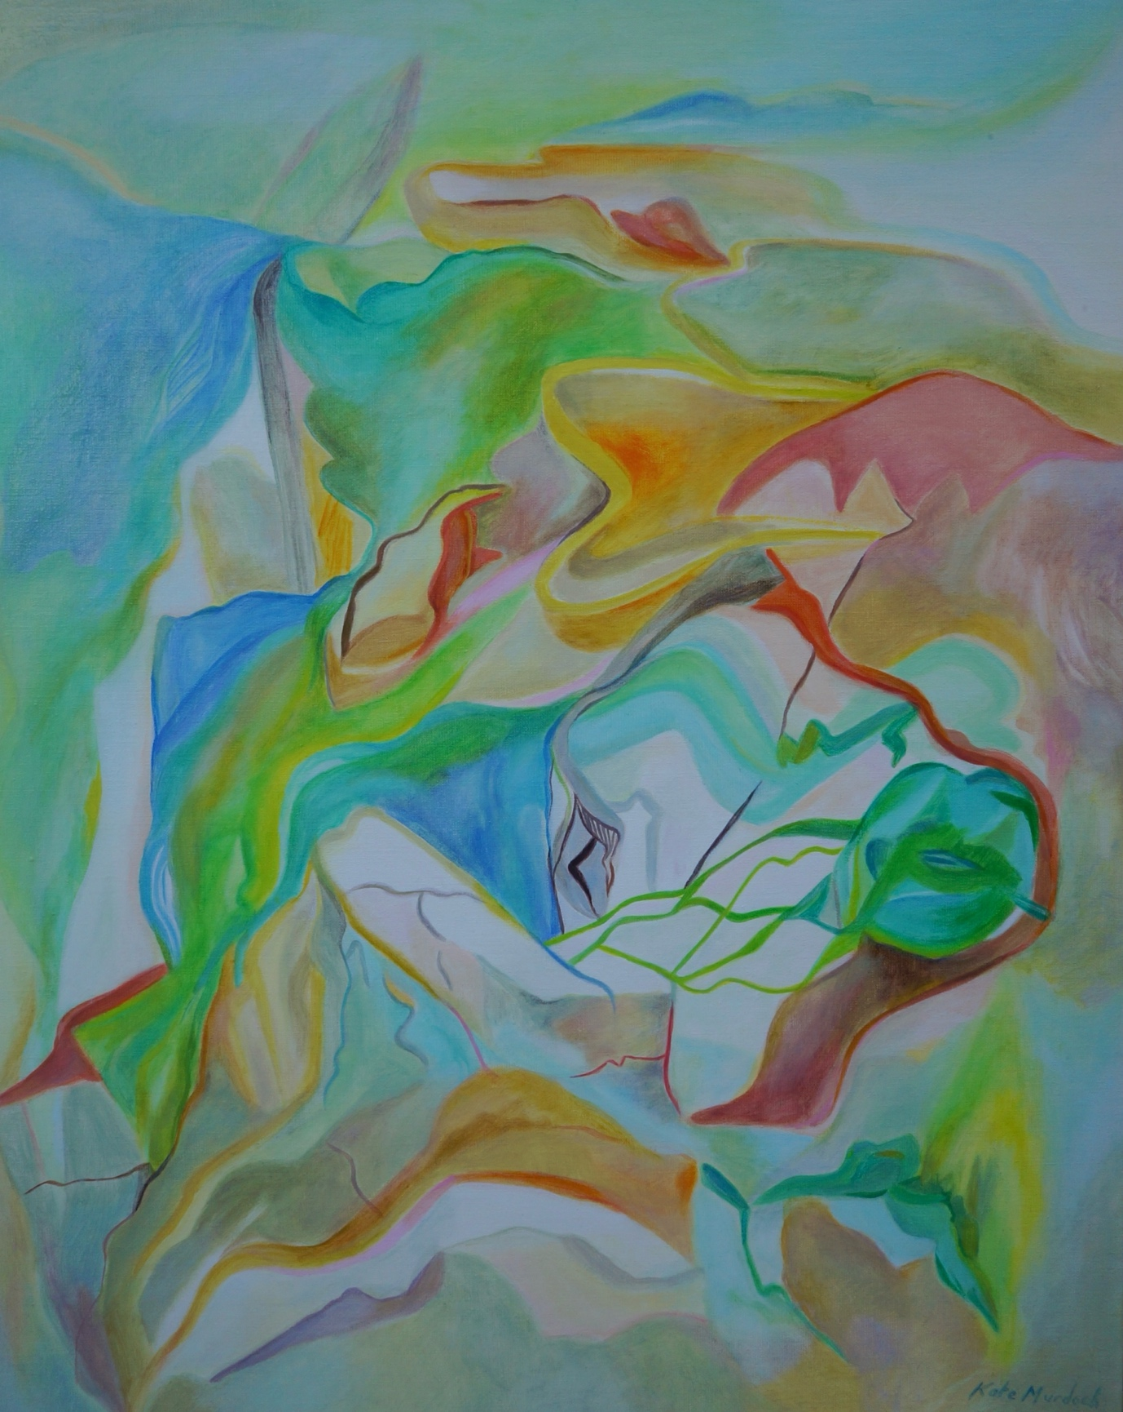
The Verge
60cm x 50cm
Oil on linen

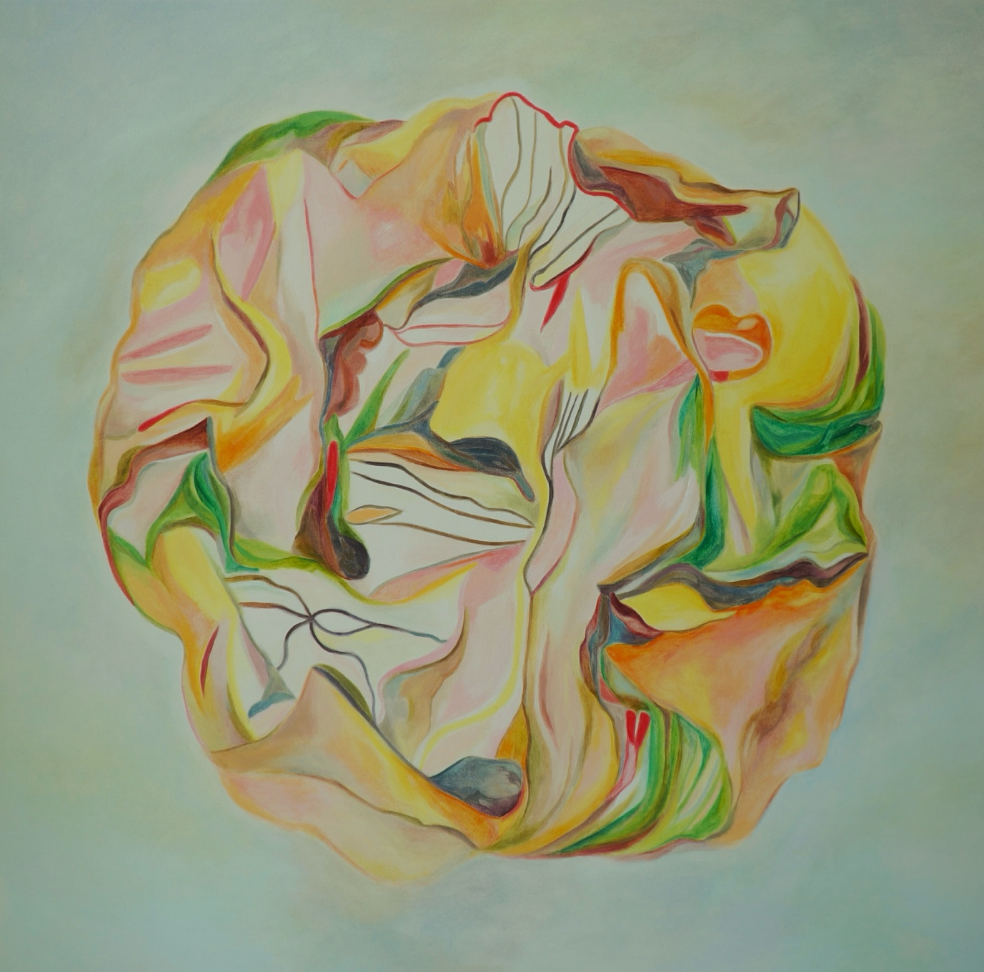
Aeolian
91cm x 91cm
Oil on canvas

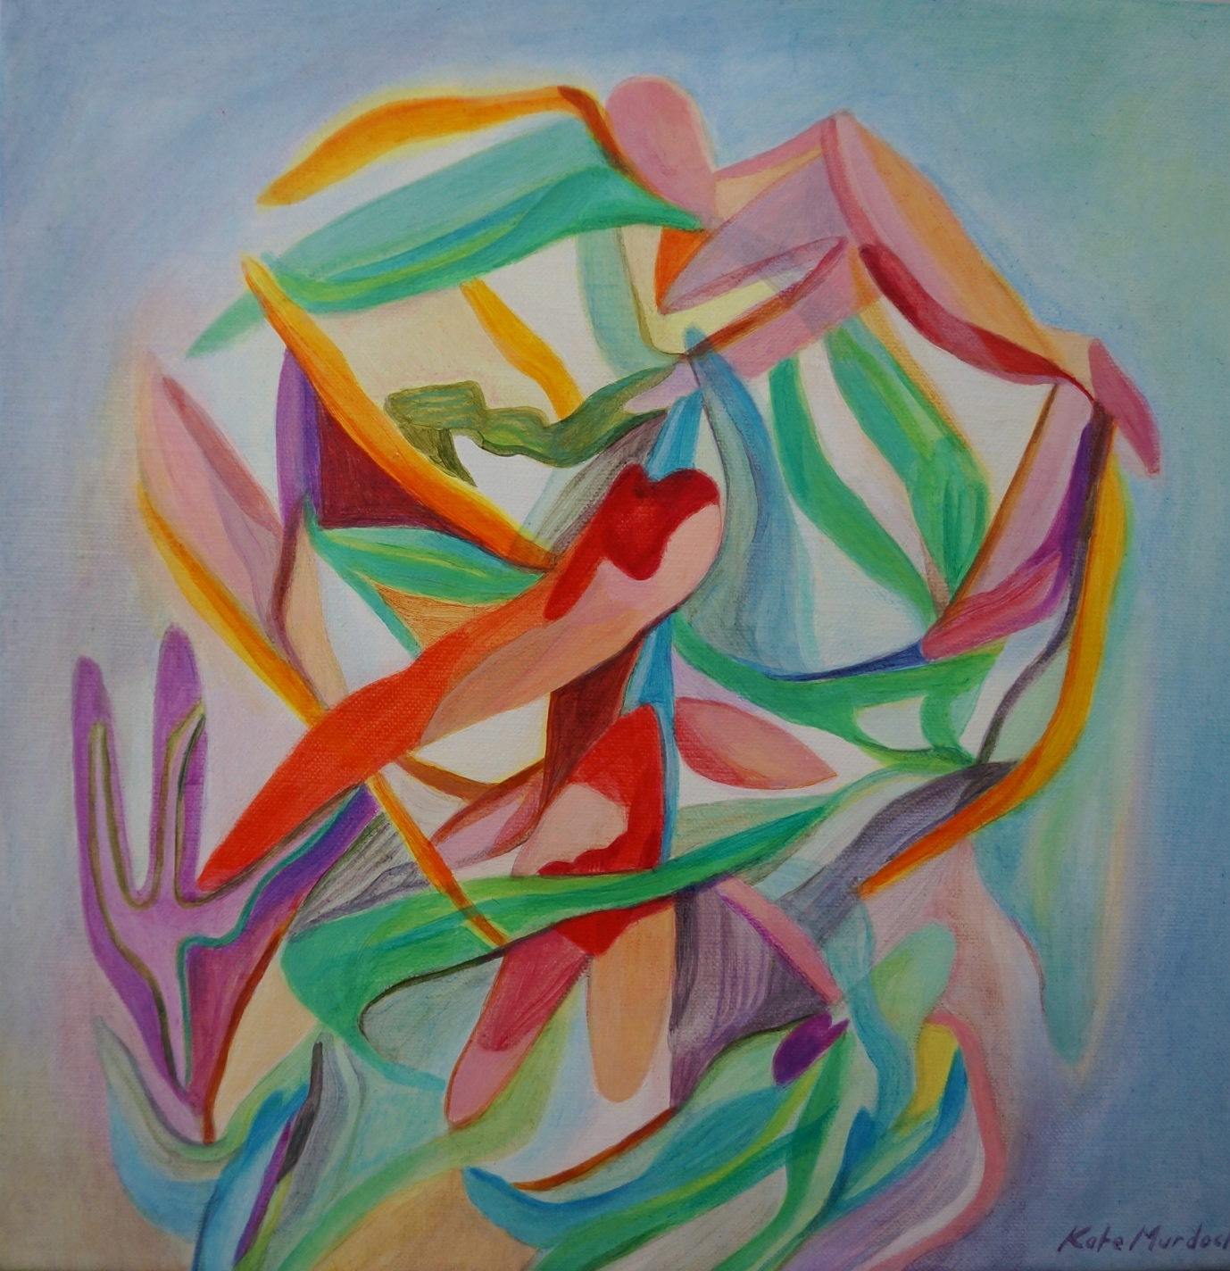
Sempre Avanti
30.5cm x 30.5cm
Acrylic on linen

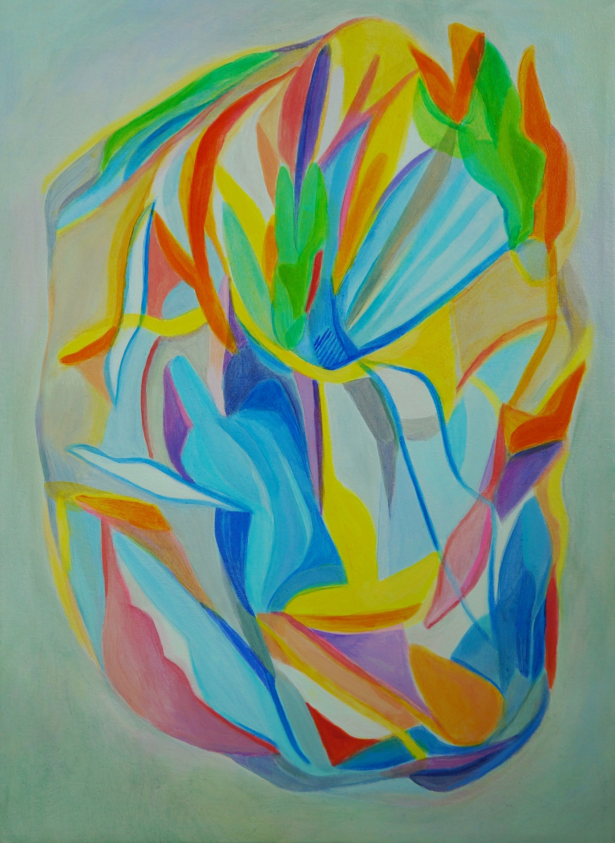
The Idea
40.5cm x 30cm
Acrylic on polycotton

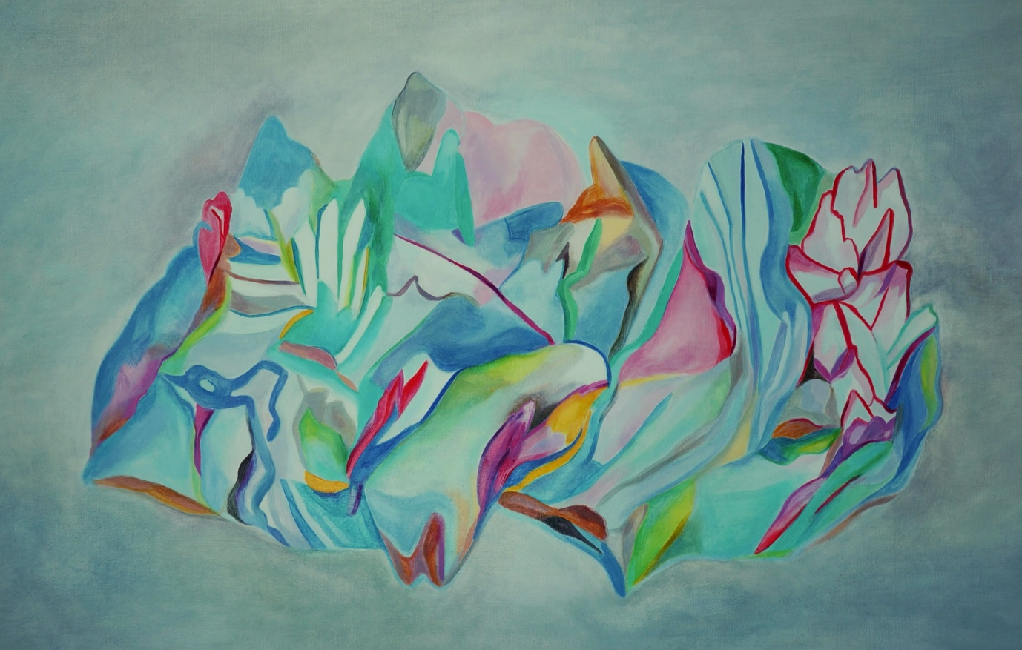
Atoll
60cm x 90cm
Oil on linen
$1800
American oak satin white frame

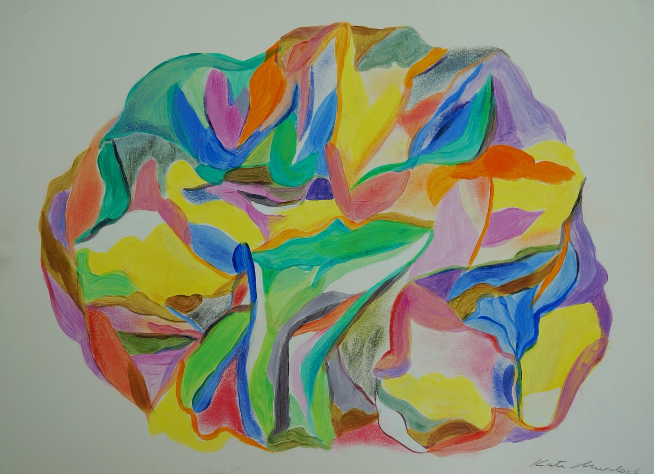
Carnevale
30cm x 40cm
Acrylic, pencil and pastel on paper

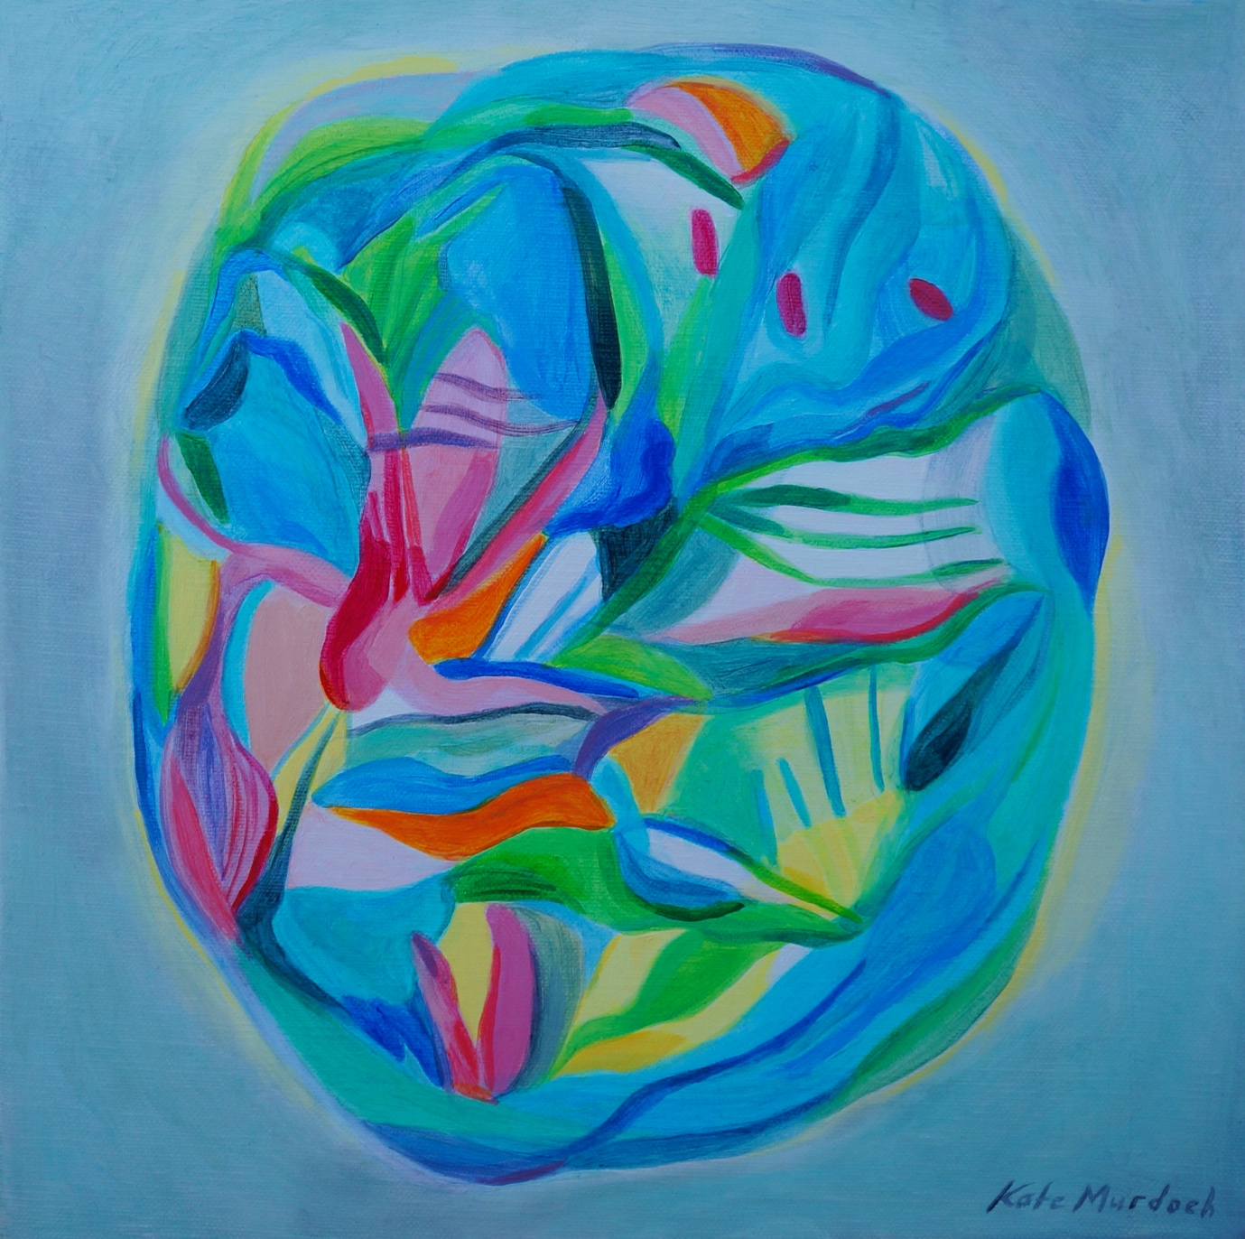
Nebula
30.5cm x 30.5cm
Acrylic on linen

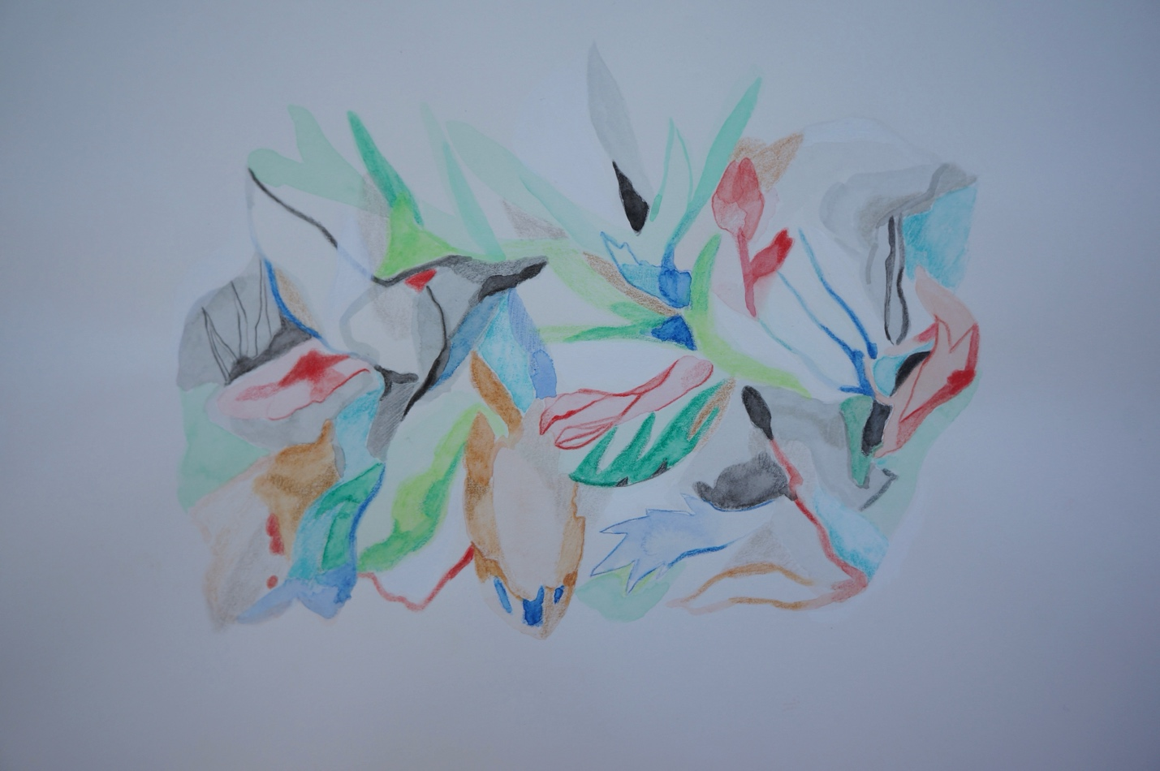
Bower
30cm x 42cm
Watercolour and pencil on Arches paper

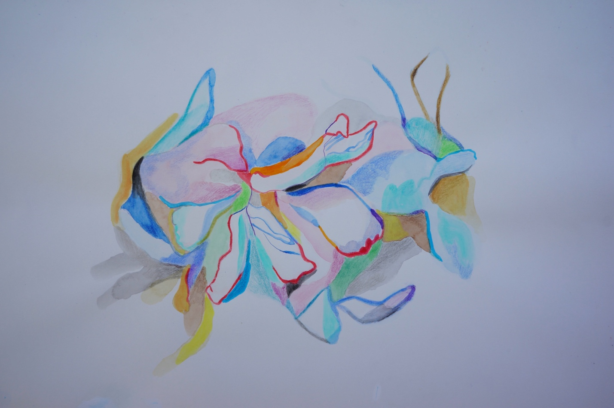
Unfurled
30cm x 42cm
Watercolour and pencil on Arches paper

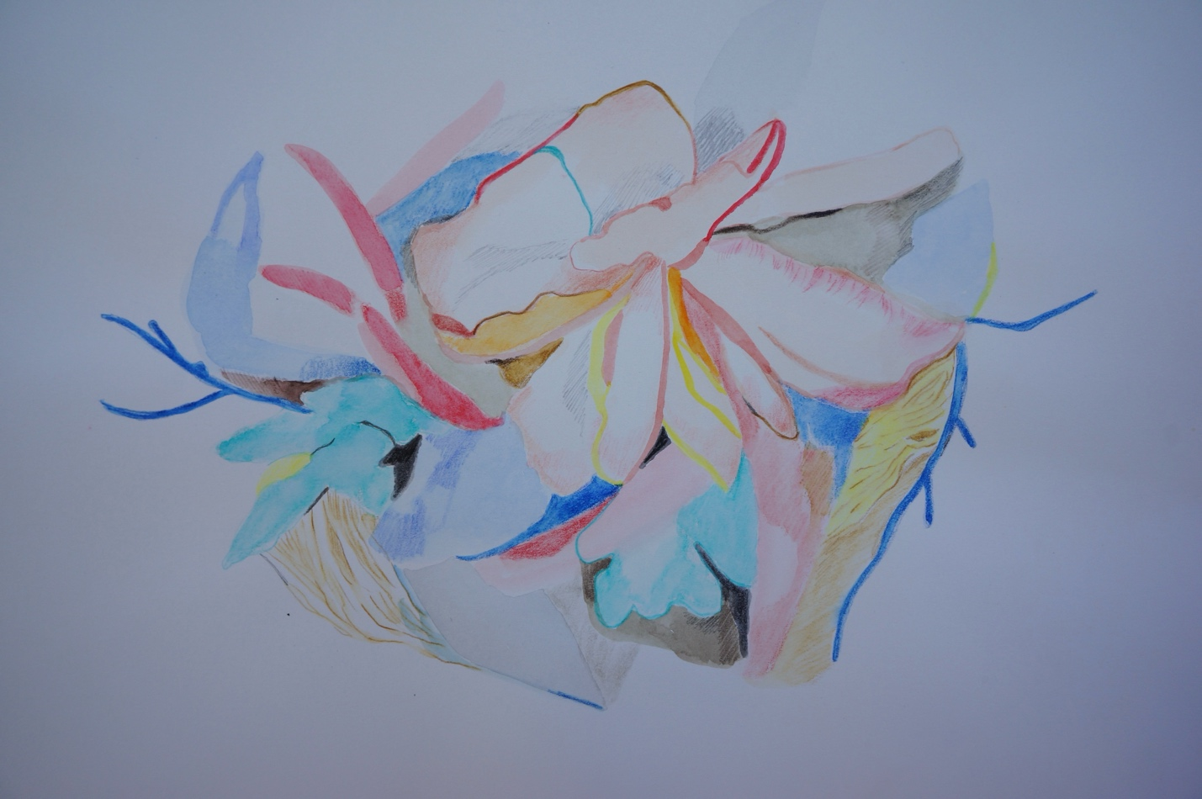
Antler Bloom
30cm x 42cm
Watercolour and pencil on Arches paper

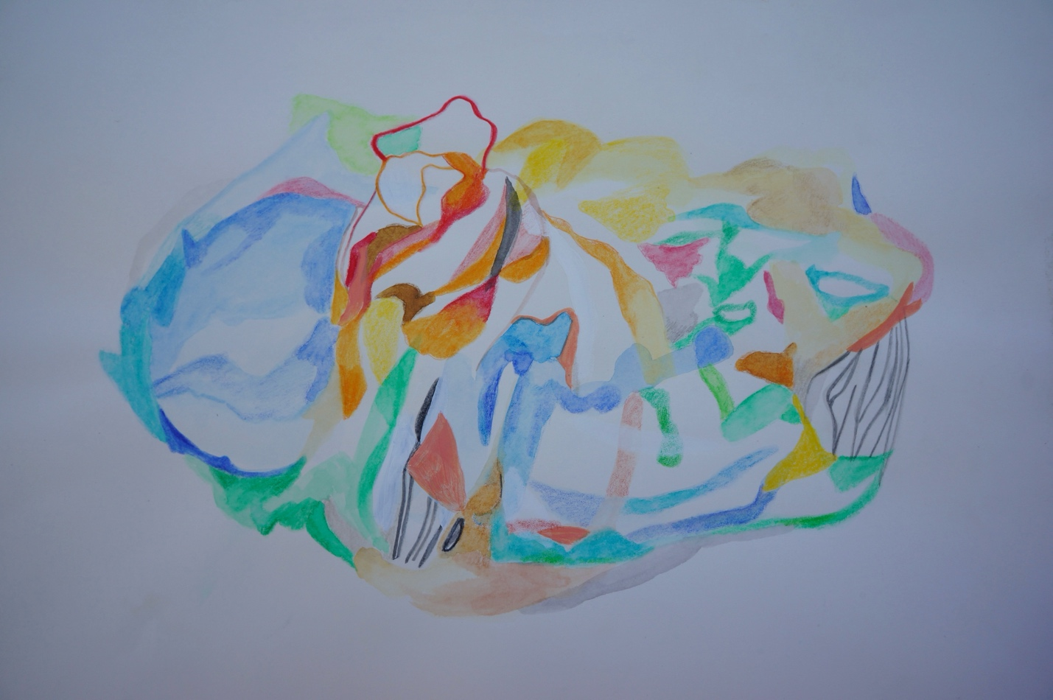
Chimera
30cm x 42cm
Watercolour and pencil on Arches paper

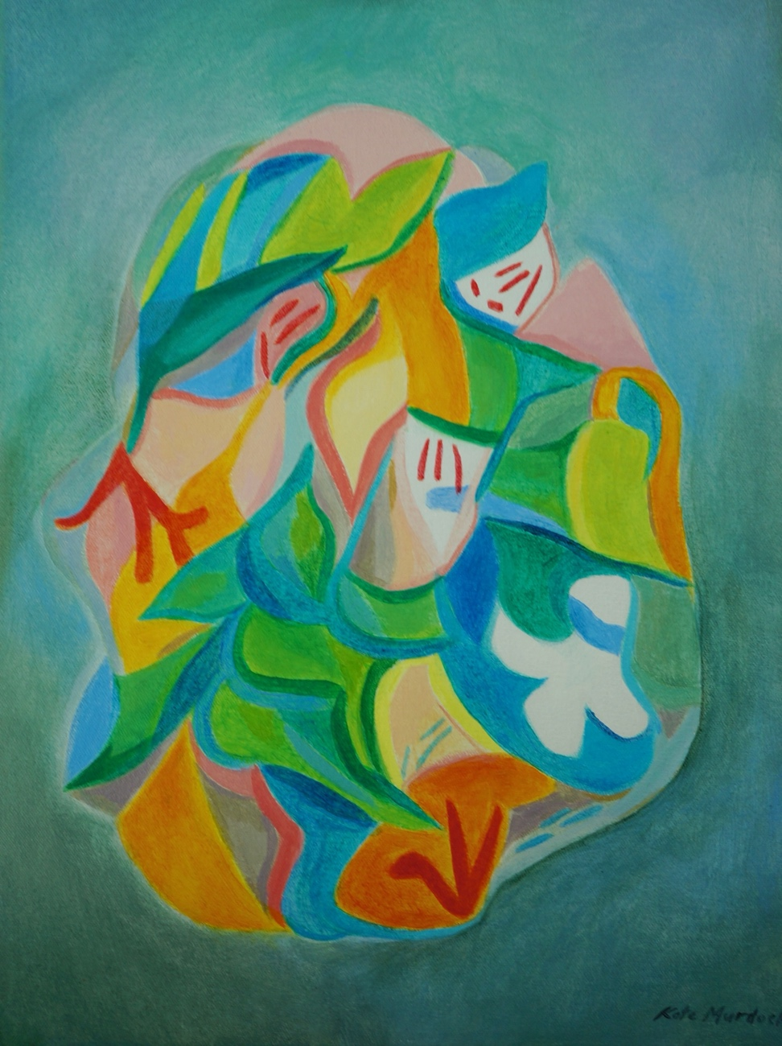
Sanctum
40.5cm x 30cm
Acrylic on canvas

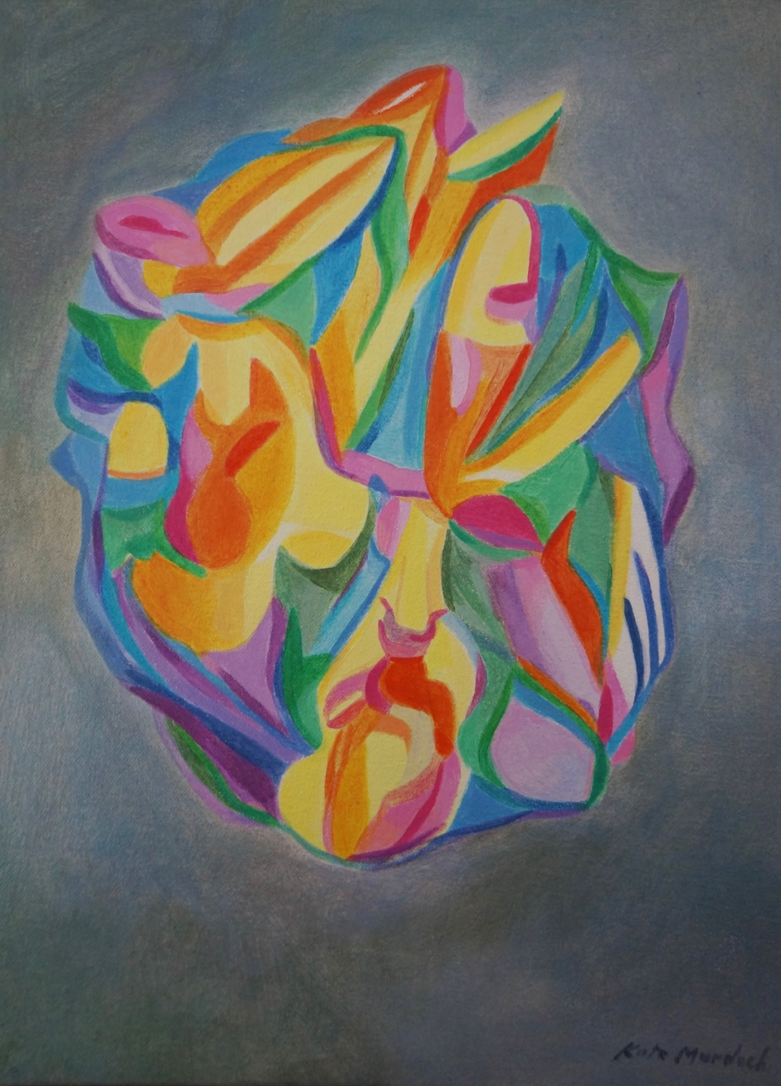
Totem
40.5cm x 30cm
Acrylic on canvas

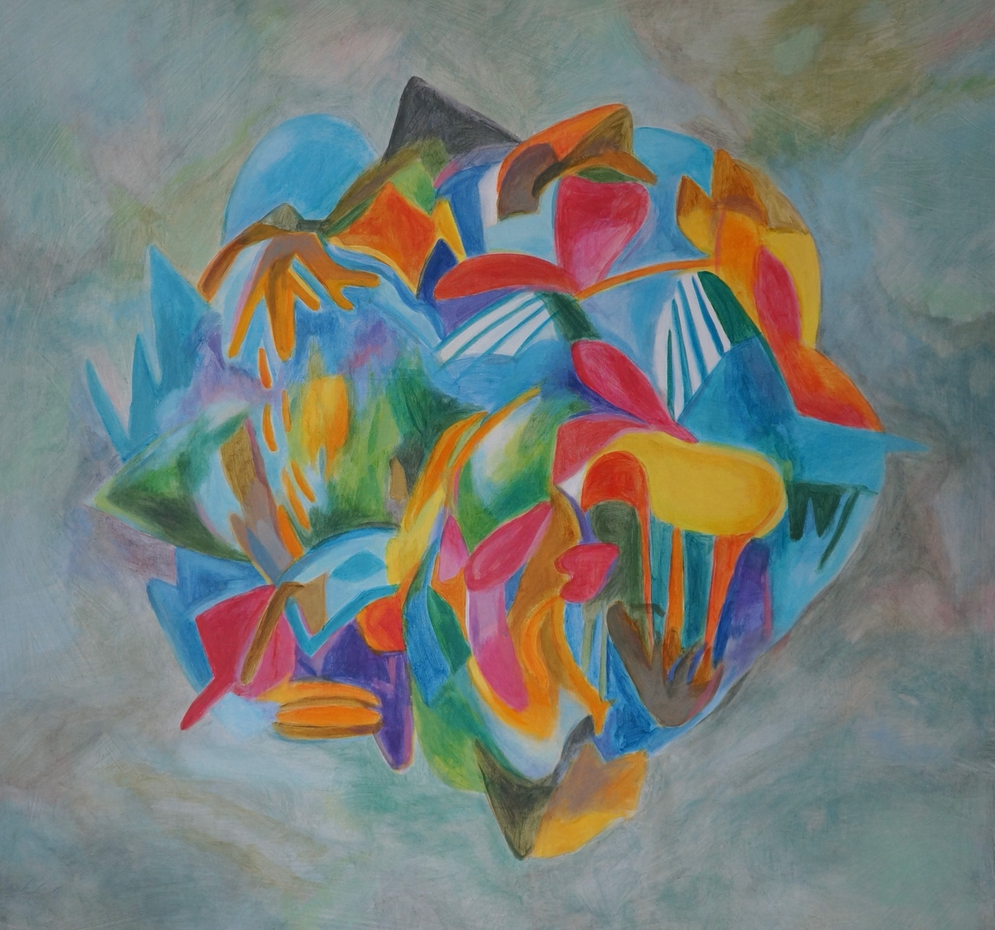
Catharsis
91cm x 91cm
Acrylic on canvas

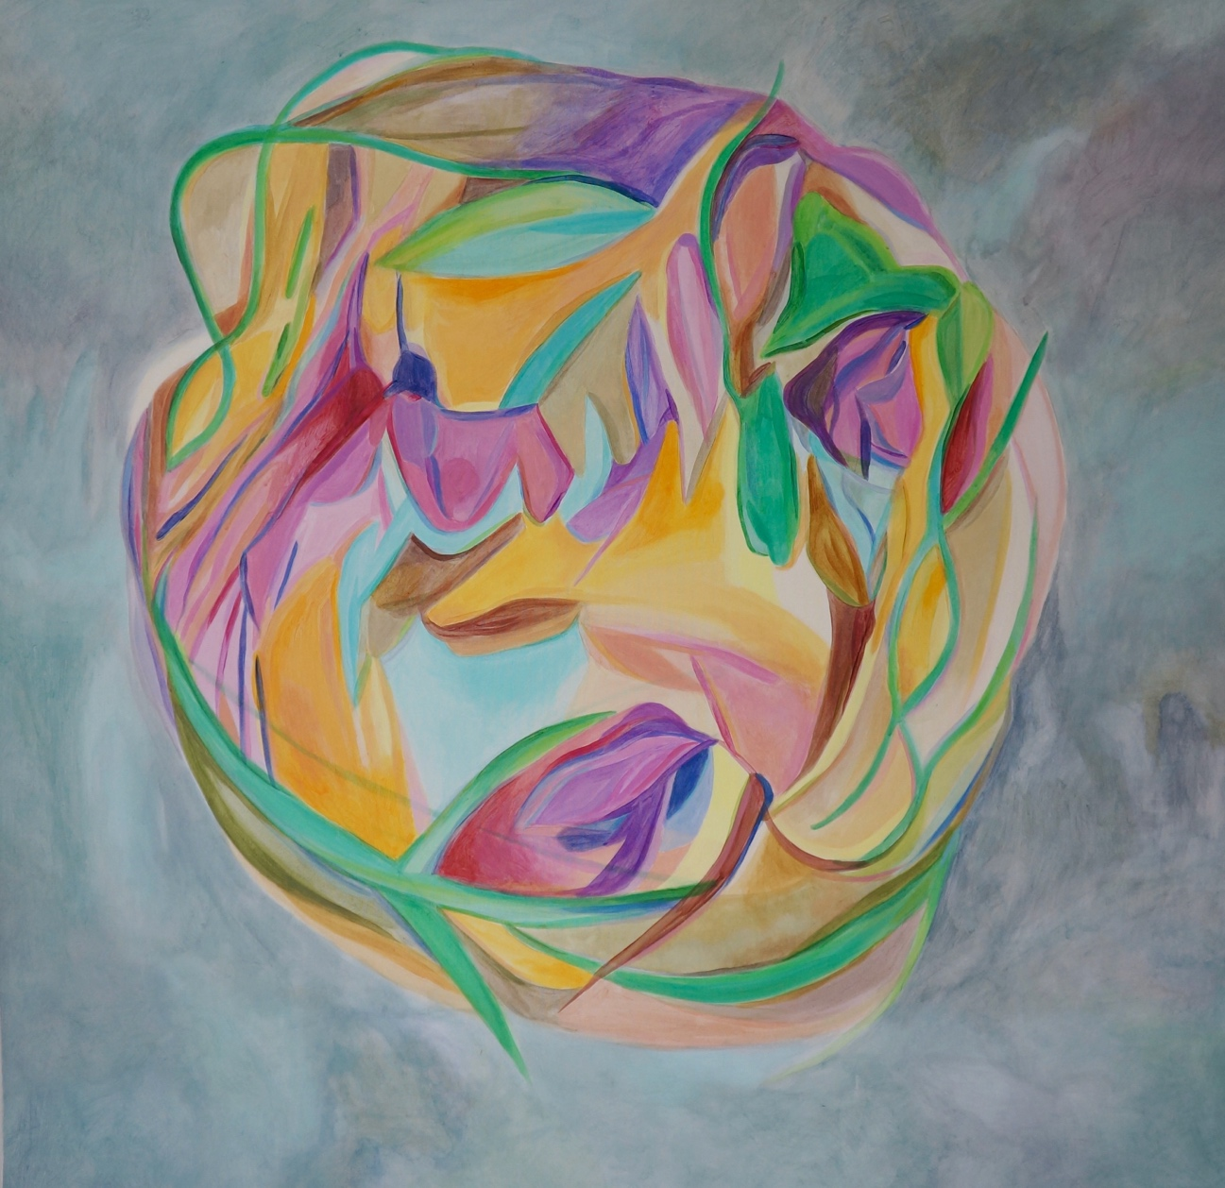
Life Cycle
97cm x 97cm
Acrylic on canvas

